Tour Reservation

For CHUNCHEON KOREA OPEN INTERNATIONAL TAEKWONDO CHAMPIONSHIPS 2019

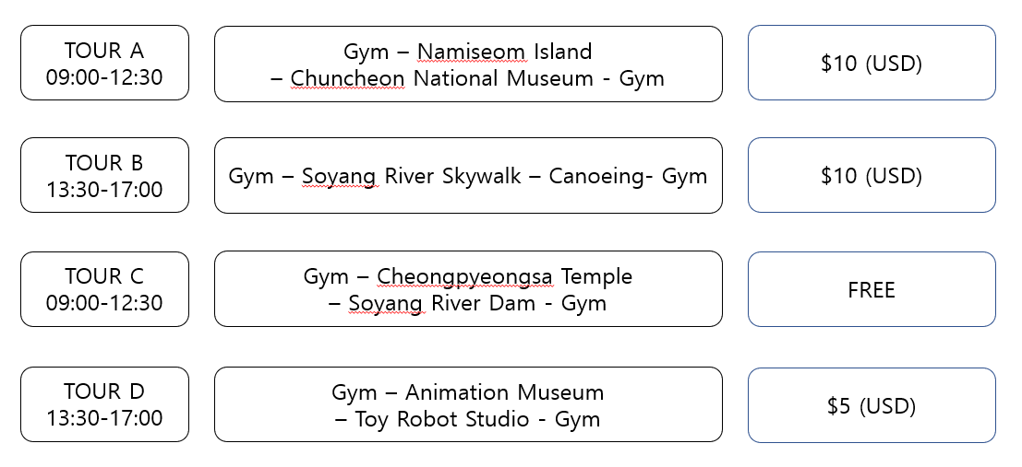

$50 (USD)
Meals are not included
$70 (USD)
$100 (USD)
-Each tour will begin and end from Gym.
-Minimum 10 people are required to operate each tour.
-All prices are for admission fee and per person in US dollars.

*TOUR B : Canoeing place is closed on Tuesday.
*TOUR D : Animation Museum and Toy Robot Studio is closed on Monday.
Tour Reservation
Nation
Leader’s name |  |  |  | Group name
E-mail address
Phone Number
Tour Course |  |  |  | No. of People
Tour Date
(Check the date you want to reserve) | July
 | 5 Fri | 6 Sat | 7 Sun |  | 8 Mon | 9 Tue | 10 Wed

Tour Information

For CHUNCHEON KOREA OPEN INTERNATIONAL TAEKWONDO CHAMPIONSHIPS 2019

Namiseom Island
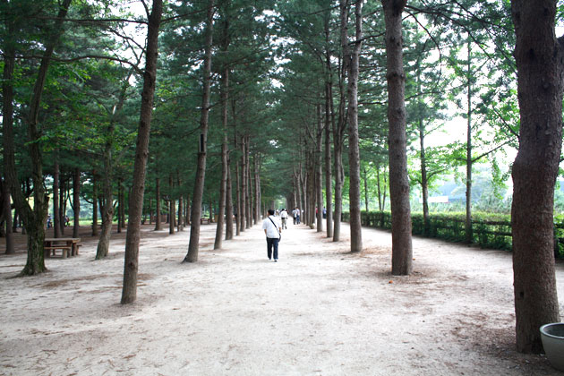
Namiseom Island, well-known as a song and fairy tale island, used to be a small peak with hill areas, but now becomes a rich repository of culture, art and natural ecology. It holds various exhibition programs and cultural events all year round.
Web: https://namisum.com/en/

Chuncheon National Museum
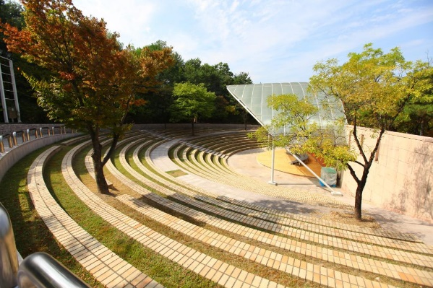
It is designed to enhance awareness about and a cultural level for local communities by holding various cultural events on research, exhibition and education in order to find and introduce the prototypes and characteristics of local cultures.
Web: http://chuncheon.museum.go.kr/html/en/

Soyang River Skywalk
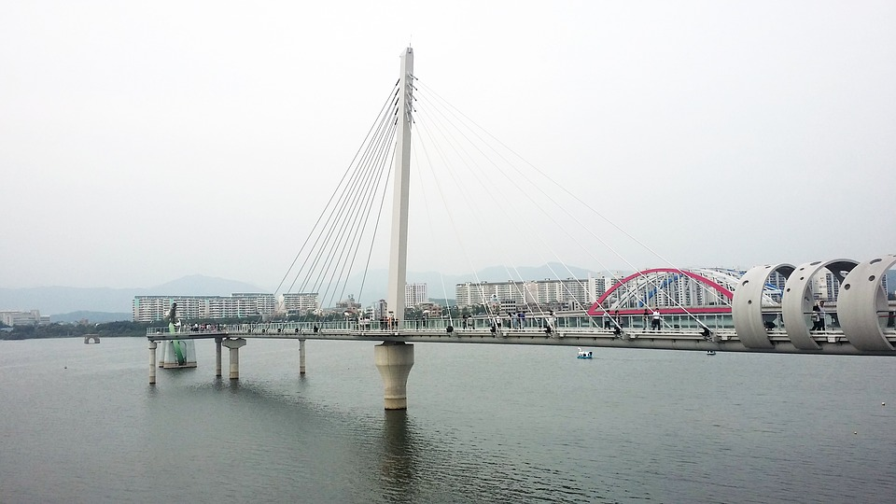
Soyanggang Skywalk, located at Yeongseo-ro, Chuncheon-si, Gangwon-do, is the longest 174-meter sky walk in Korea with the 156m-long transparent-glassed floor. The floor is spread of three sheets of special toughened glass for safety.
Wed:http://romantic.chuncheon.go.kr/portal/E20000/E20300/E20304/tourDetail?thema=Sights&sub=observatory&no=250475

Canoeing
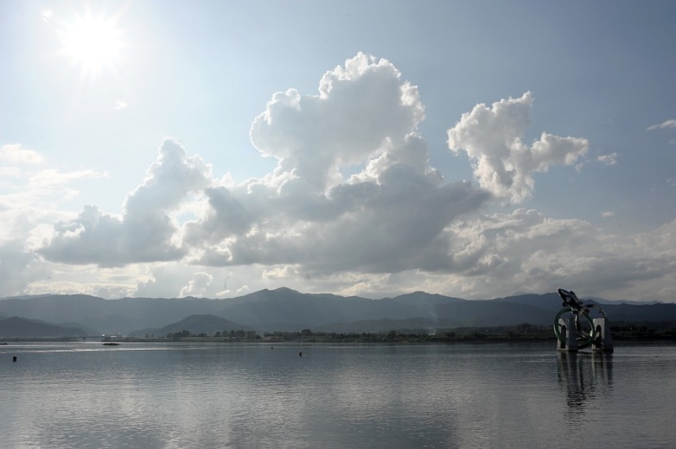
Mulle-gil Trail is located at Uiamho Lake, Chuncheon. It is very popular with tourists because they can feel happiness through safe canoes which are romantic and can accommodate many people.
Web: http://www.mullegil.org/eng/index.php

Cheongpyeongsa Temple
Cheongpyeongsa Temple is located on the beautiful misty slopes of Obongsan Mountain, and can be reached after enjoying a 10minute ferry ride from Soyang Lake Ferry Dock. The temple was built in 973 during the reign of King Gwangjong of the Goryeo Dynasty.

Toy Robot Studio
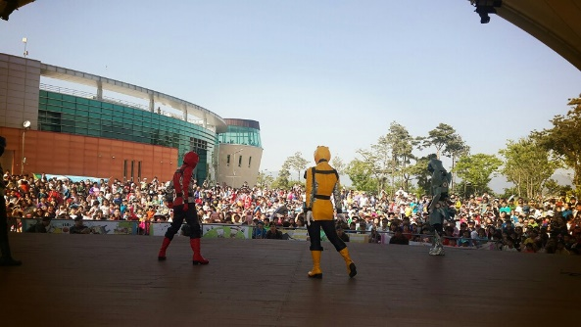
Robot Studio is an experiential exhibition hall that presents a vision of the future robotics, featuring experiment robots, robot avatars, and reproduction of movie scenes. The studio offers a family friendly setting, featuring a toy room, building block games, 4D-media room, robot camp, and more.
Web: http://robotstudio.kr/hb/robot

Animation Museum
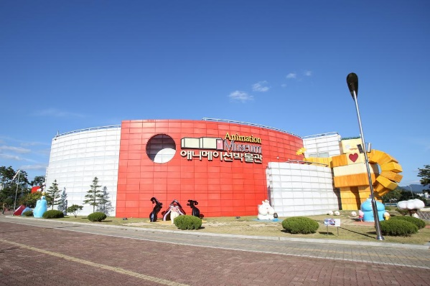
Animation Museum is located in Seo-myeon, Chuncheon-si, Gangwon-do. It is the first animation specialized museum in Korea. It is on the lakeside, Uiamho Lake and offers a nice view. Also, various animation characters are set up out of the museum.
Web:http://romantic.chuncheon.go.kr/portal/E20000/E20200/E20204/tourDetail?thema=Sights&sub=ruins&no=10173

Soyang Dam
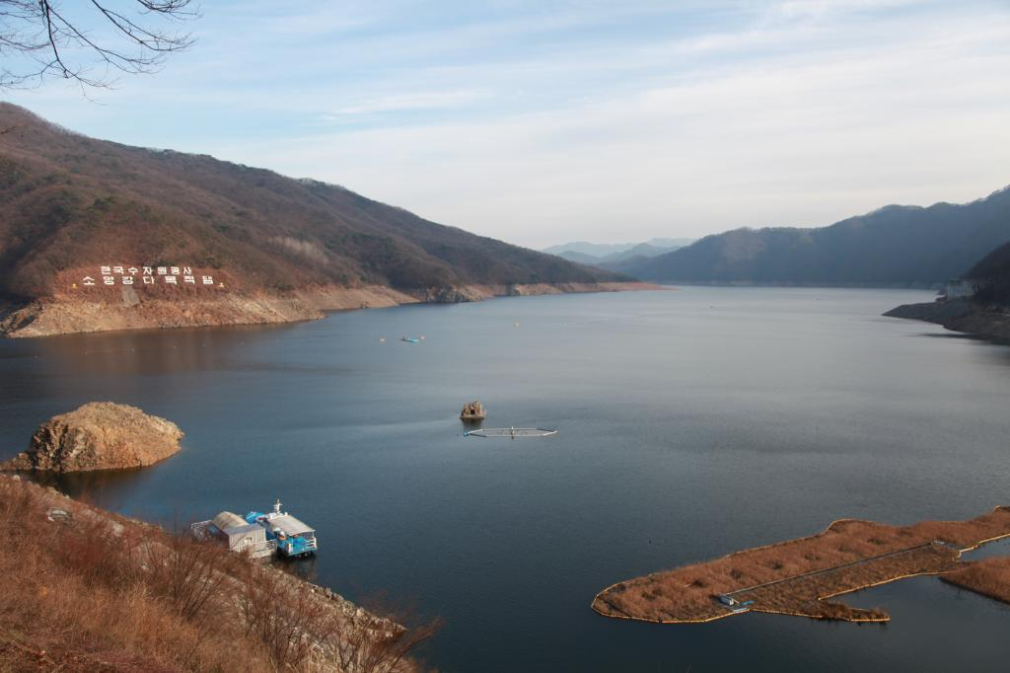
Soyangho Lake is a place formed after building Soyang Dam, the largest multipurpose dam in the East. It looks so magnificent that it is called Inland Sea.
Web:http://romantic.chuncheon.go.kr/portal/E20000/E20100/E20104/tourDetail?thema=Sights&sub=lake&no=10404

Chuncheon City Tourist Information Website: http://romantic.chuncheon.go.kr/portal/index

*All source for Tour information is Gangwon Tourism Organization and Korea Tourism Organization.

