Accommodation

For CHUNCHEON KOREA OPEN INTERNATIONAL TAEKWONDO CHAMPIONSHIPS 2019

The Organizing Committee of the Chuncheon Korea Open International Taekwondo Championships 2019 has prepared the accommodation for the participants and accompanying people during the championships. All reservation requests for accommodation will be handled by RYE Tour, Official Travel Agency of Chuncheon Korea Open International Taekwondo Championships 2019.
Package Rate
Price : per person / night
Type | Name | Room Type |  |  | Meals
 |  | Double /Twin |  | Single
Athletes’ Village | Hallym University Dormitory | $65 |  | $75 | Breakfast, Lunch and Dinner
Hotel | Benikea Bears Tourist Hotel | $75 |  | $110 | Breakfast and Lunch
 | Chuncheon Sejong Hotel
 | The Venezia Suite Hotel
 | Chuncheon Tourist Hotel | $65 |  | $100 | Lunch
Resort | Elysian Resort (Gangchon)* |  | $80 | $110 | Breakfast and Lunch
 | *Triple Room : USD 60P/N Quad Room : USD 50P/N 5PAX : USD 45P/N
Accommodation Information
Hallym University Dormitory | 1 Hallymdaehak-gil, Chuncheon-si, Gangwon-do, Korea  Tel.+82 33 259 4701-2 Fax.+82 33 257 7037
Benikea  Bears Hotel | 376, Sports town-gil, Chuncheon-si, Gangwon-do, Korea  Tel.+82 33 256 2525 Fax.+82 33 256 2530
Chuncheon  Sejong Hotel | 31, Bonguisan-gil, Chuncheon-si, Gangwon-do, Korea  Tel.+82 33 252 1191 Fax.+82 33 254 3347
Chuncheon  Tourist Hotel | 30-1 Nakwon-dong, Chuncheon-si, Gangwon-do Korea  Tel.+82 33 257 1900 Fax +82 33 257 3388
The Venezia  Suite Hotel | 136, Hyoja-ro, Chuncheon-si, Gangwon-do, Korea  Tel.+82 33 255 9600 Fax +82 33 255 9610
Elysian Resort (Gangchon) | 688, Bukhangangbyeon-gil, Namsan-myeon, Chuncheon-si, Gangwon-do, Korea  Tel.+82 33 260 2000 Fax.+82 33 264 6013
RYE Tour
Mail | #309, Dong-A Bldg.  7, Gukhoe-daero 70-gil  Yeongdeungpo-gu, Seoul  07238 Korea | Tel | +82 2 725-0808
 |  | Fax | +82 2 761-4808
 |  | E-mail | ryetour11@gmail.com  ryetour01@gmail.com
Reservations are proceeded first come first served on a basis, and you are kindly advised to return your completed reservation form by 30 May, 2019. Transportation will be provided between Incheon airport and Chuncheon, the venue city from 2 ~ 4, July (3 days) for the Arrival and 10 ~ 11, July for the departure. Complete the reservation form as indicated and submit it by fax, e-mail or direct mail to the address below. For further inquiry, please contact RYE Tour.
Accommodation Reservation
For 2019 CHUNCHEON KOREA OPEN INTERNATIONAL TAEKWONDO CHAMPIONSHIP

Accommodation Choice |  |  | Group Size (Number of Group Members)
Athletes’ Village | Hallym University Dormitory |  | Team Leader | M | F
 |  |  | Athletes
Hotel | Benikea Bears Hotel
 | Chucheon Sejong Hotel |  | Doctor
 | Chuncheon Tourist Hotel |  | Coach
 | The Venezia Suite Hotel |  | Accompanying Persons
Resort | Elysian Resort  (Gangchon) |  | Total
 |  |  |  | :
Flight Schedule
Arrival | Departure
Date | Date
Time | Time
Number of Pax | Number of Pax
Flight Number | Flight Number
From | From
To | To
Accommodation Needed
 | 7/2 Tue | 7/3 Wed |  | 7/4 Thu |  | 7/5 Fri |  | 7/6 Sat |  | 7/7 Sun |  | 7/8 Mon |  | 7/9 Tue |  | 7/10 Wed
 | □Athletes Village (□Benikea Bears/ □Sejong /□Tourist /□The Venezia) Hotel
Single
Double/Twin
 | □Elysian Resort
Triple
Quad
5pax/1rm
Basic Information
Nation
Leader’s name | Group name
Mailing address
Phone Number | Fax no.
E-mail address
Accommodation Pictures (1)

Athletes’ Village | 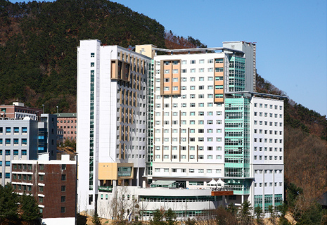 | 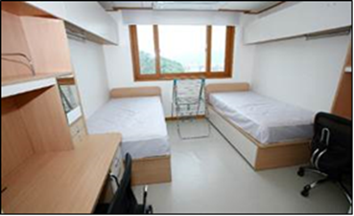
Benikea Bears Hotel | 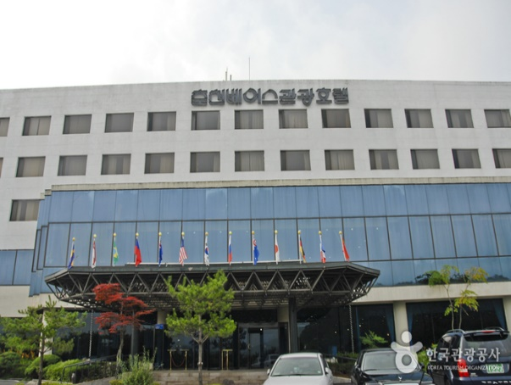 | 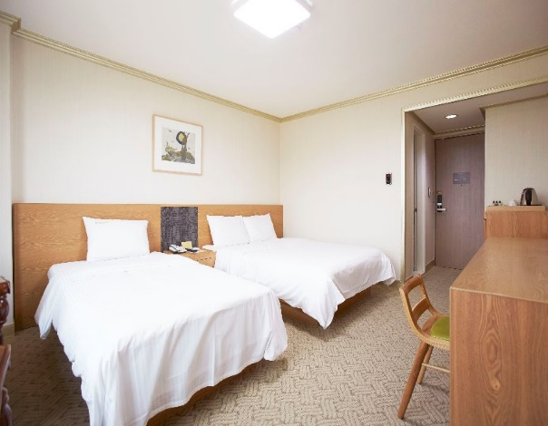
Chuncheon  Sejong Hotel | 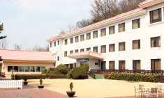 | 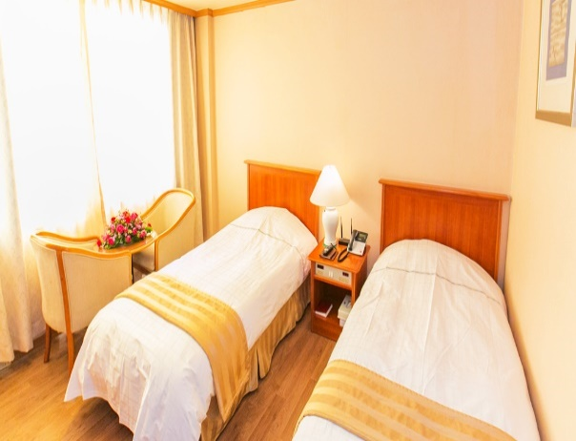

Accommodation Pictures (2)

Chuncheon  Tourist Hotel | 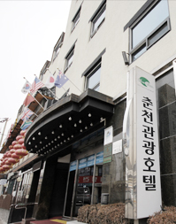 | 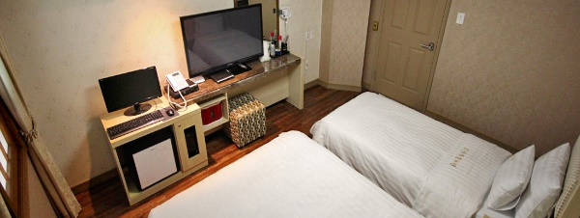  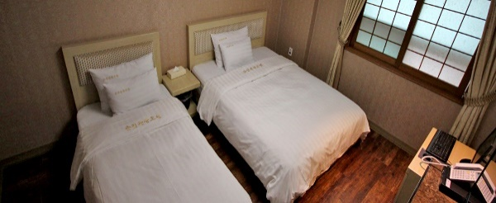
The Venezia  Suite Hotel | 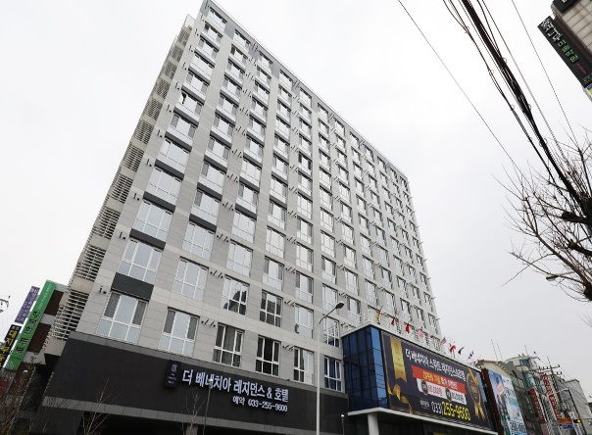 | 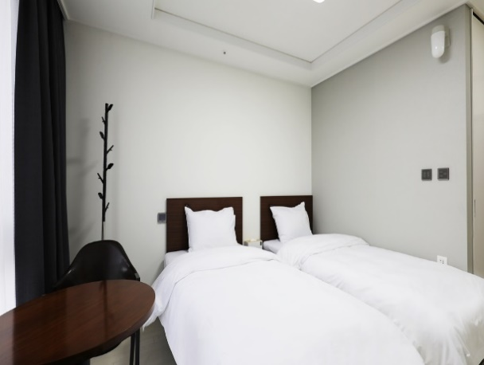
Elysian Resort (Gangchon) | 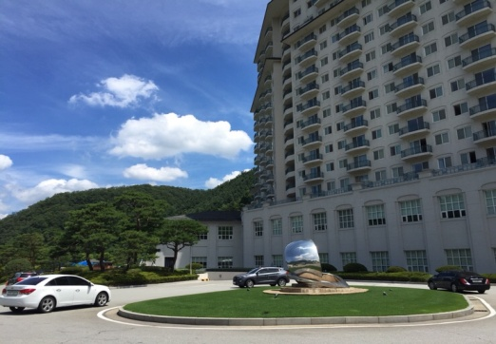 | 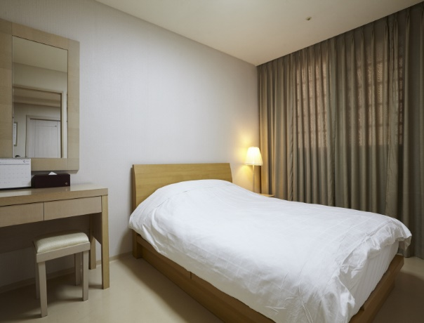

Return this form to
Official Travel Agency Chuncheon Korea Open International Taekwondo Championships 2019
RYE Tour Co., Ltd.
#309 Dong Ah Bldg. 7 Gukhoe- daero 70-gil, Youngdeungpo-gu, 07238 KOREA
Tel. (REP) +82 2 725 0808, (DIR/ Hyunji Lee) +82 2 761 6808
Fax. +82 2 761 4808
E-mail: ryetour11@gmail.com
THE ORGANIZING COMMITTEE
Organizing Committee of Chuncheon Korea Open International Taekwondo Championships 2019
Hoban Gymnasium, #30-1 Seoksa-dong, Chuncheon-si, Gwangwon-do 200-932 Korea
Tel.++82 33 250 3647~8, 250-3648~9 Fax.++82 33 250 3650, 261-3647 E-mail: kocitc@hotmail.com
Homepage: www.chuncheonkoreaopen.org

