Tour Reservation

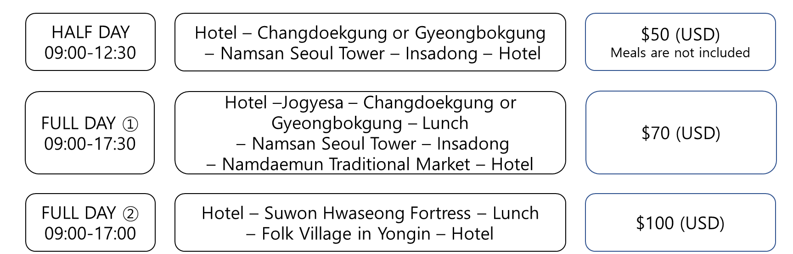
For KIMUNYONG CUP INTERNATIONAL OPEN TAEKWONDO CHAMPIONSHIPS 2019

$50 (USD)
Meals are not included
$70 (USD)
$100 (USD)

-Each tour will begin and end from Hotel.
-Minimum 10 people are required to operate each tour.
-All prices are per person in US dollars.
Tour Reservation
Nation
Leader’s name |  |  |  | Group name
E-mail address
Phone Number
Tour Course |  |  |  | No. of People
Tour Date
(Check the date you want to reserve) | July
 | 12 Fri | 13 Sat | 14 Sun |  | 15 Mon | 16 Tue | 17 Wed

