**HOTEL RESERVATION FORM**

|  |  |
| --- | --- |
| ***For JEJU KOREA OPEN INTERNATIONAL TAEKWONDO CHAMPIONSHIPS 2018*** | ***July 18 -24, 2018*** |

The Organizing Committee of the JEJU Korea Open International Taekwondo Championships 2018 has prepared the accommodation and tour packages for the participants and accompanying people during the championships. All reservation requests for accommodation and tour package will be handled by Rye Tour, Official Travel Agency of JEJU Korea Open International TKD Championships 2018.

Reservations are proceeded first come first served on a basis, and you are kindly advised to return your completed reservation form by 30 June, 2018. Please complete the reservation form as indicated and submit it to [ryetour11@gmail.com](mailto:ryetour11@gmail.com)

IMPORTANT NOTICE  
Since JEJU is an island, IT’S IMPOSSIBLE TO TRAVEL THERE BY CAR FROM INCHEON AIRPORT, YOU CAN GO THERE BY FLIGHT ONLY.  
THUS, WE RECOMMEND YOU CHOOSE YOUR FINAL DESTINATION AS JEJU (CJU) BY FLIGHT, at your best convenience.

|  |  |  |  |  |
| --- | --- | --- | --- | --- |
| **Package Rate** | | Price : **per person / night** | | |
| **Hotel Name** | **Room Type** | | | **Meals** |
| **Double** | | **Single** |
| Jeju Oriental Hotel | US$70 | | US$110 | Breakfast |
| Ramada Jeju City Hotel | US$70 | | US$110 | Breakfast |
| Shalom Hotel | US$70 | | US$110 | Breakfast |
| Hotel The One | US$70 | | US$110 | Breakfast |

|  |  |
| --- | --- |
| **Accommodation Information** | |
| Jeju Oriental Hotel | 47 Topdong ro, Jeju city, Jeju-do, Korea  Tel. +82-64-752-8222 |
| Ramada Jeju City Hotel | 304, Jungang-ro, Jeju city, Jeju-do, Korea  Tel. +82-64-759-8831 |
| Shalom Hotel | 34 Donggwang-ro, Jeju city, Jeju-do, Korea  Tel. +82-64-720-7704 |
| Hotel The One | 33 Sajang 3 gil, Jeju city, Jeju-do, Korea  Tel. +82-64-798-0001 |

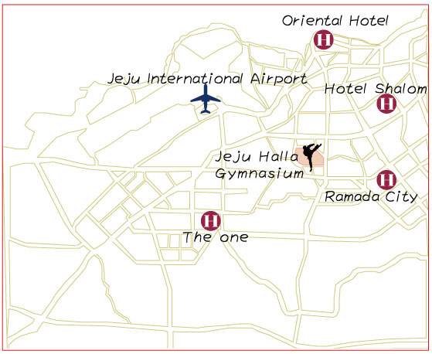

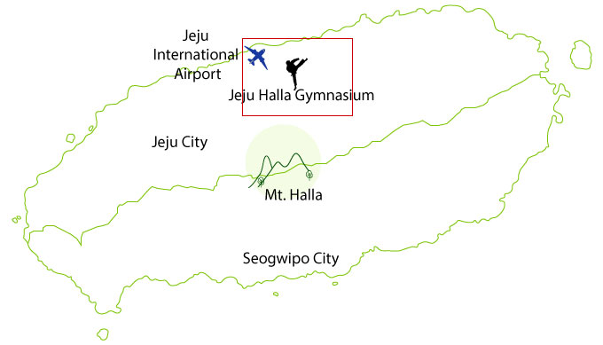

**Jeju International Airport to Halla Gymnasium:**   
About 10 minutes by car, 2.6km

**HOTEL RESERVATION FORM**

|  |  |
| --- | --- |
| ***For JEJU KOREA OPEN INTERNATIONAL TAEKWONDO CHAMPIONSHIPS 2018*** | ***July 18 -24, 2018*** |

|  |  |  |  |
| --- | --- | --- | --- |
| **Basic Information** | | | |
| Nationality |  | | |
| Leader’s name |  | Group name |  |
| Address |  | | |
| Phone Number |  | Fax no. |  |
| E-mail |  | | |

|  |  |  |  |
| --- | --- | --- | --- |
| **International & Domestic Flight Schedule** | | | |
| Arrival | | Departure | |
| Arrival Date |  | Departure Date |  |
| Number of People |  | Number of People |  |
| International Flight No. |  | International Flight No. |  |
| From |  | From |  |
| Departure Time |  | Departure Time |  |
| To |  | To |  |
| Arrival Time |  | Arrival Time |  |
| Domestic Flight No. |  | Domestic Flight No. |  |
| From |  | From |  |
| Departure Time |  | Departure Time |  |
| To |  | To |  |
| Arrival Time |  | Arrival Time |  |

|  |  |  |  |  |  |  |
| --- | --- | --- | --- | --- | --- | --- |
| **Hotel & Room Selections** | | | | | | |
| Hotel | Number of rooms | | | Check in date | Check out date | Total nights of stay |
| Double | Single | Total |  |  |  |
| Jeju Oriental Hotel ( ) |  |  |  |  |  |  |
| Ramada Jeju City Hotel ( ) |  |  |  |  |  |  |
| Shalom Hotel ( ) |  |  |  |  |  |  |
| Hotel The One ( ) |  |  |  |  |  |  |

**\*Please tick your hotel choice, and fill in your room preference.**

|  |  |
| --- | --- |
| **Return this form to:** | |
| **Address** | #309, Dong-A Bldg, 7, Gukhoe-daero 70-gil, Yeongdeungpo-gu, Seoul, 07238 Korea |
| **Tel** | +82 2 725-0808 |
| **Fax** | +82 2 761-4808 |
| **E-mail** | ryetour11@gmail.com |

**HOTEL INFORMATION**

|  |  |
| --- | --- |
| ***For JEJU KOREA OPEN INTERNATIONAL TAEKWONDO CHAMPIONSHIPS 2018*** | ***July 18 -24, 2018*** |

**Jeju Oriental Hotel**

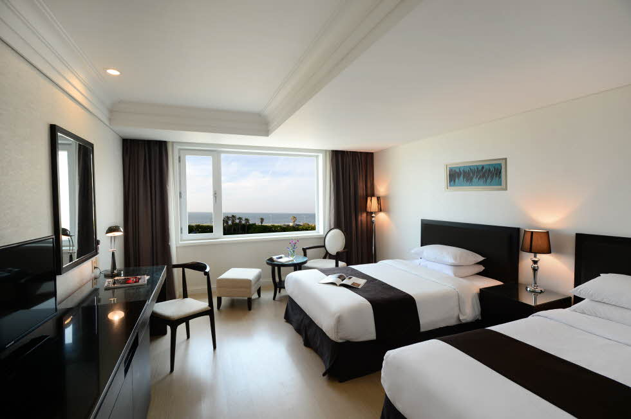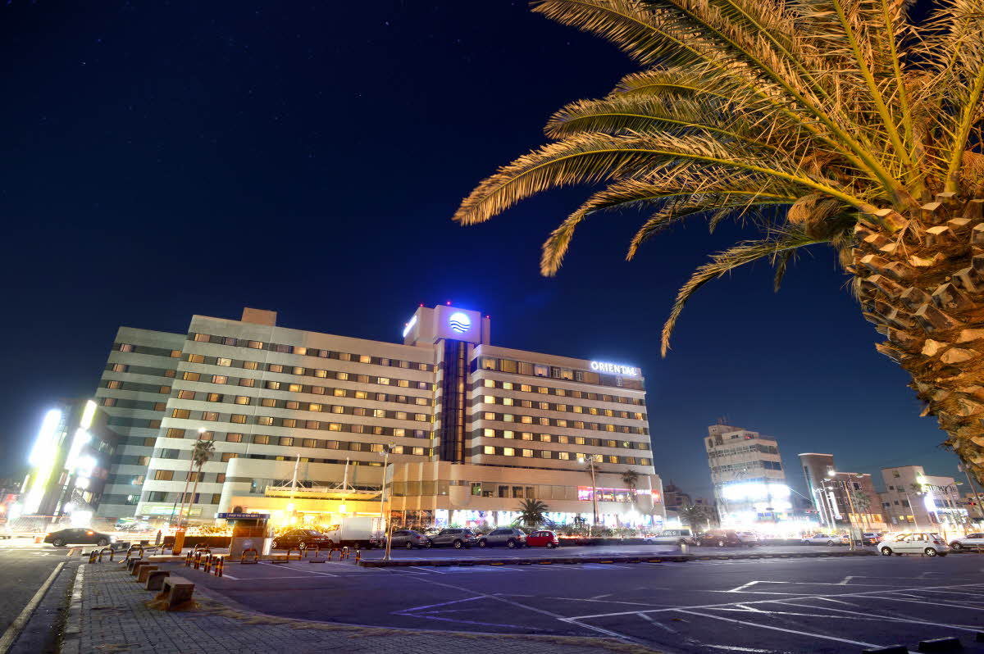

**Access  
Jeju International Airport to Hotel:** 12 minutes, about 3.6 km  
**Hotel to Halla Gymnasium:** 10 minutes, about 2.5km

**Facility**

- Casino

- Sauna

- Screen Golf Club

- Business Center

**Room facility**

LCD TV, Free internet, CATV, Mini bar, Refrigerator, Personal strongbox, Radio, Air conditioning controller. Bidet, Dressing table, Table and chair, wardrobe

**Amenities**  
Slippers, Memo pad , Hair drier, Bathrobe, Shower cap, Comb, Sanitary bag, Make-up cotton, Cotton swab, Bath towel, Skin lotion, Lotion, Soap, Towel, Whirlpool, Shampoo, Electronic mosquito repeller, Electronic pot, Teacup, Teabag, A water glass, Mineral water.

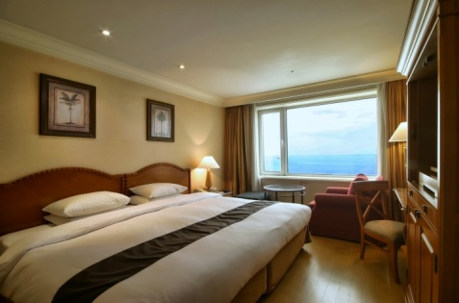

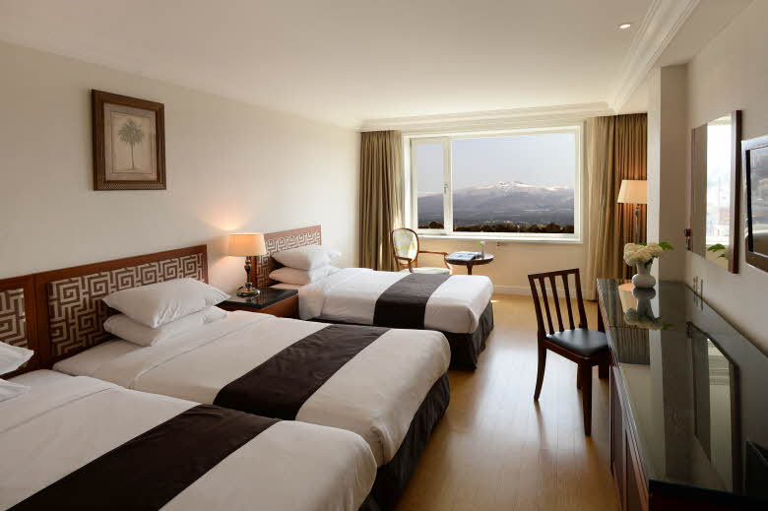

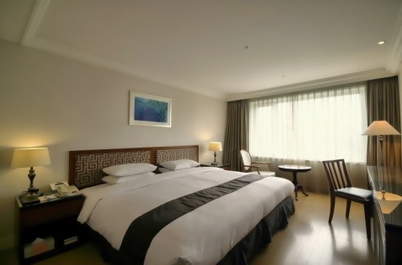

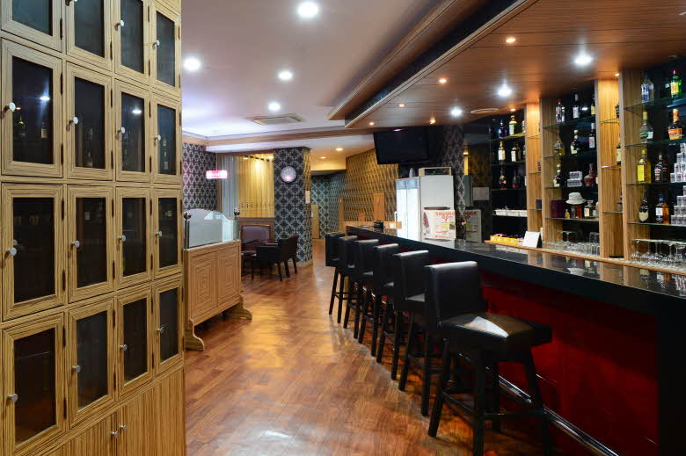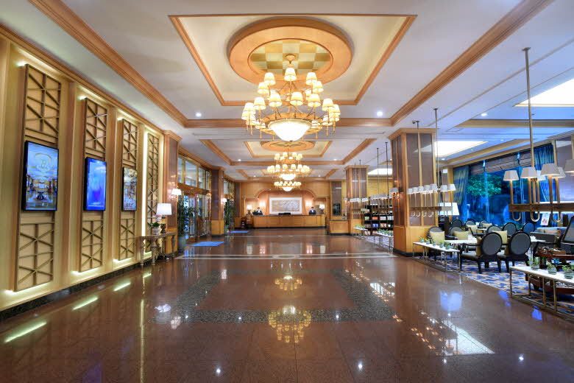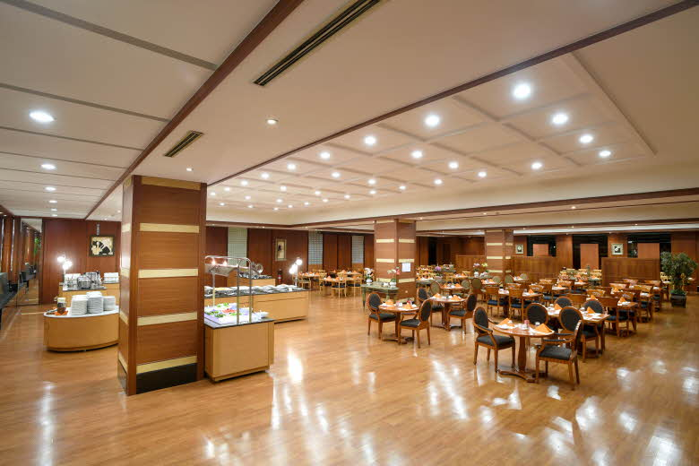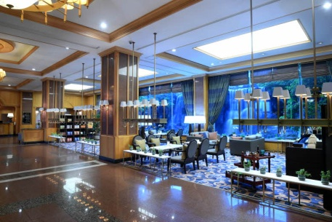

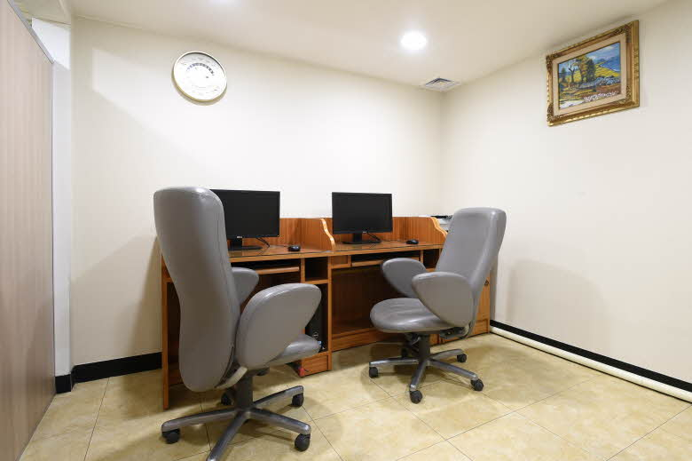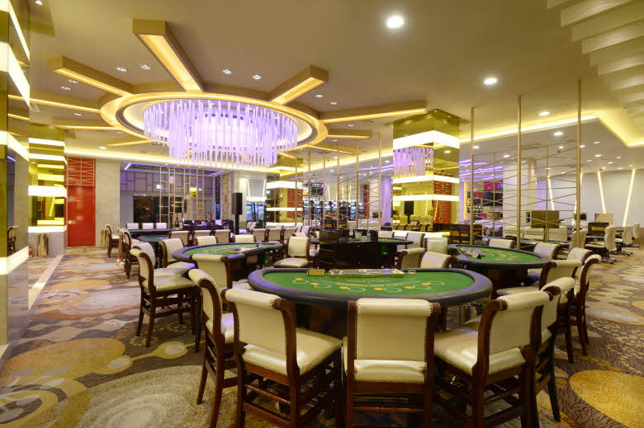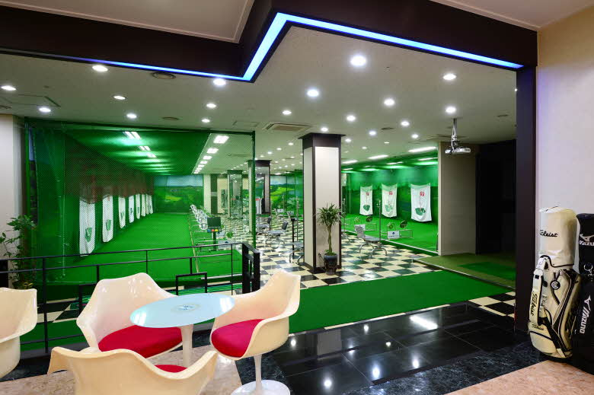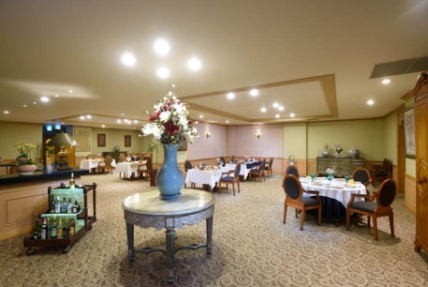

** HOTEL INFORMATION**

|  |  |
| --- | --- |
| ***For JEJU KOREA OPEN INTERNATIONAL TAEKWONDO CHAMPIONSHIPS 2018*** | ***July 18 -24, 2018*** |

**Ramada Jeju City Hotel**

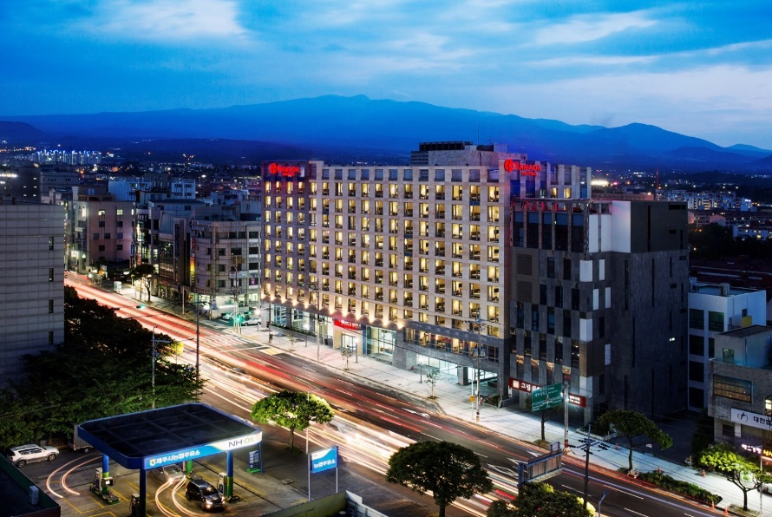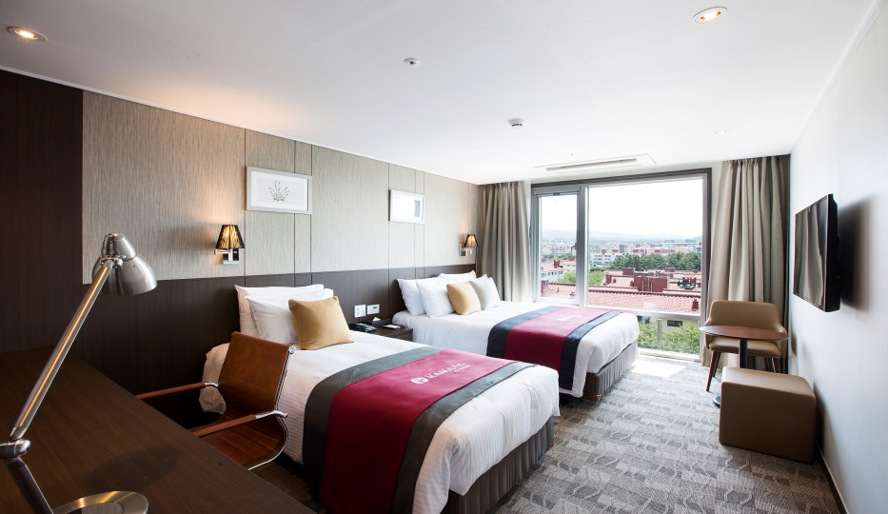

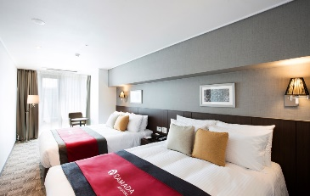

**Access  
Jeju International Airport to Hotel:** 15 minutes, about 5 km  
**Hotel to Halla Gymnasium:** 10 minutes, about 2.9km

**Facility**

- Business center

- Fitness center

- Restaurants and cafe

- Convenience store

- Roof top garden

**Room facility**

42″ HDTV, Teapot, Telephone, Refrigerator, Indoor slippers, Bathrobe, Hair Dryer, Shampoo, Conditioner, Shower gel, Body lotion, Soap, Shower cap, Cotton swab, hair comb, bidet.

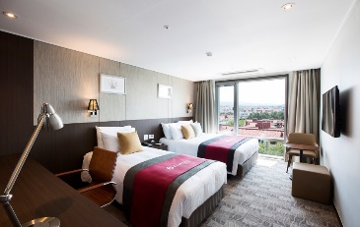

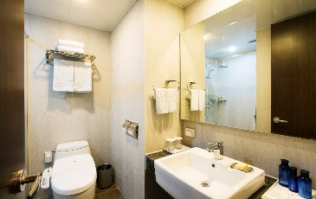

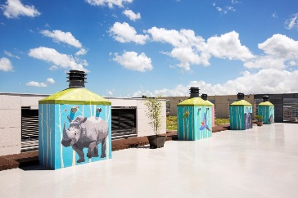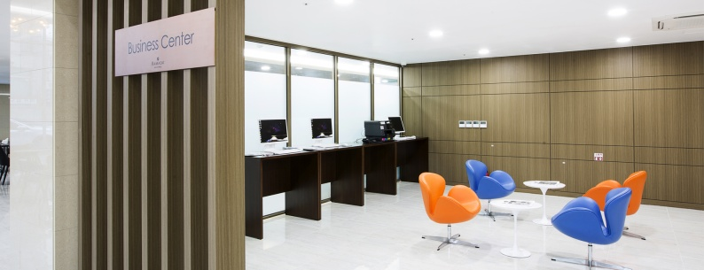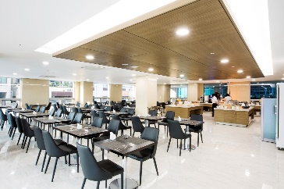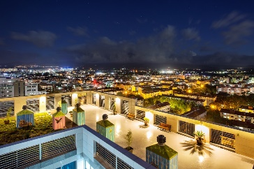

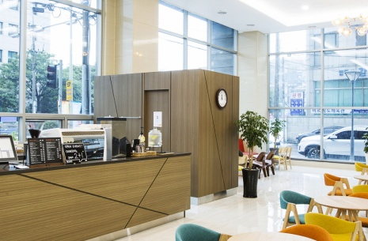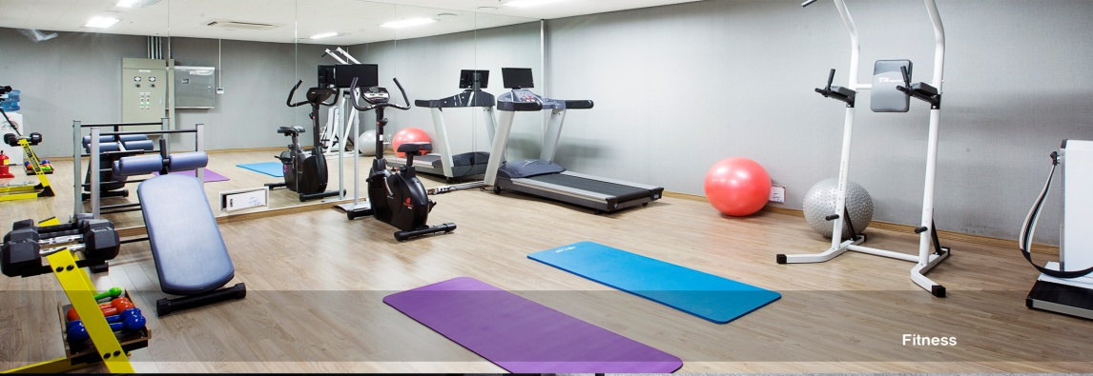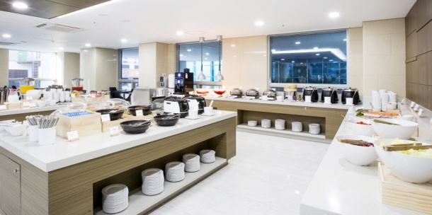

** HOTEL INFORMATION**

|  |  |
| --- | --- |
| ***For JEJU KOREA OPEN INTERNATIONAL TAEKWONDO CHAMPIONSHIPS 2018*** | ***July 18 -24, 2018*** |

**Shalom Hotel**

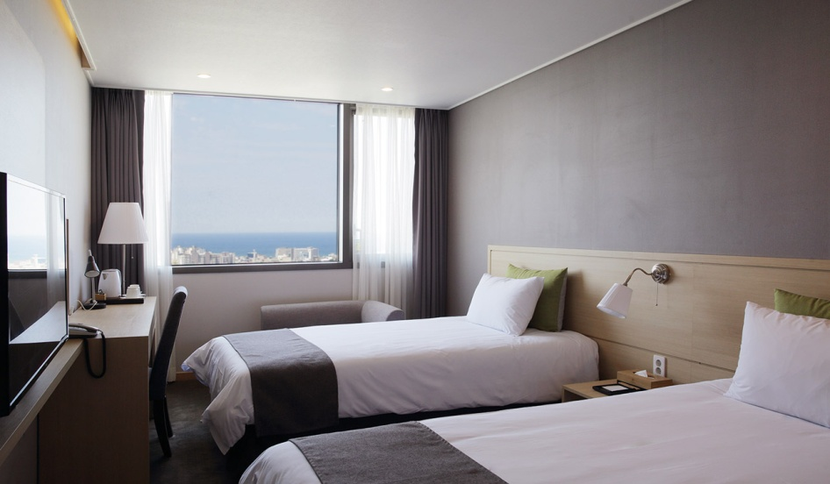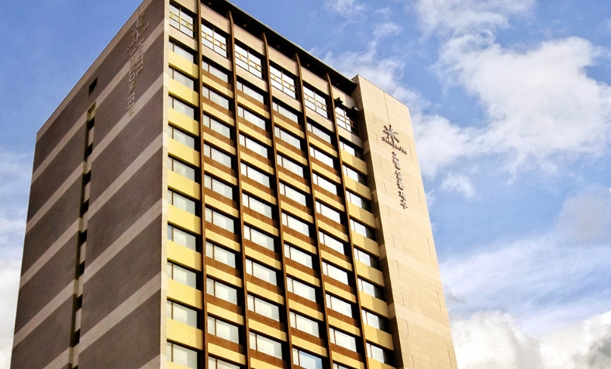

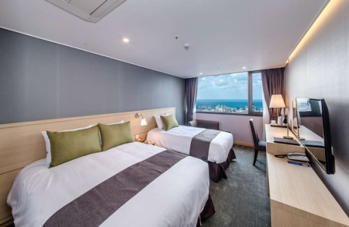

**Access  
Jeju International Airport to Hotel:** 15 minutes, about 4.3 km

**Hotel to Halla Gymnasium:** 8 minutes, about 2.1km

**Facility**

- Restaurant

- Fitness center

- Banquet & seminar

- Meeting room

**Room facility**

50″ LED TV - 170 Channels, Telephone, Refrigerator, Electric Kettle / Cps, 2 free bottles of mineral water provided per day, free tea service, bidet, hair drier, soap, shampoo, rinse, body wash and body lotion, bath robes, shower cap, cotton swabs, face towels and bath towels.

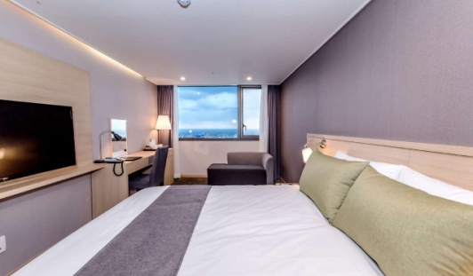

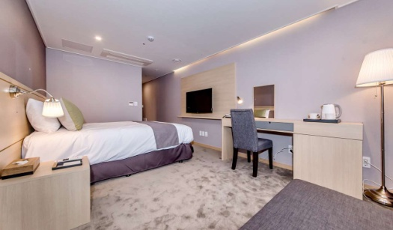

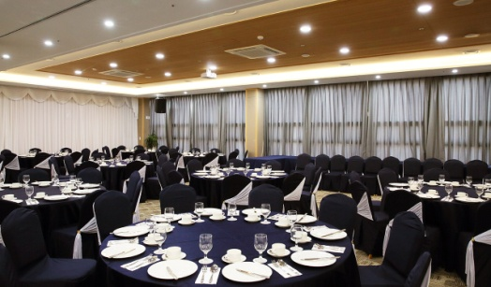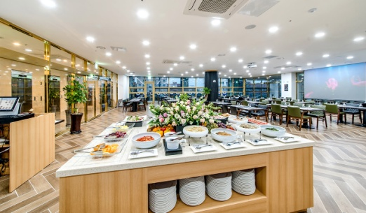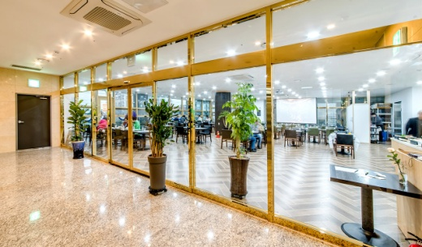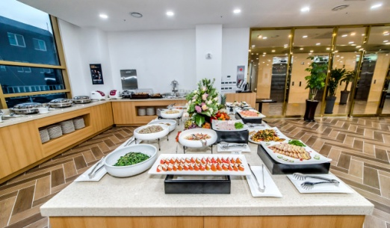

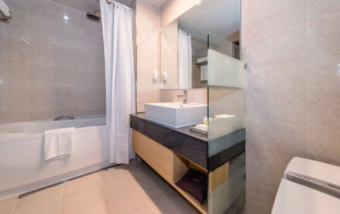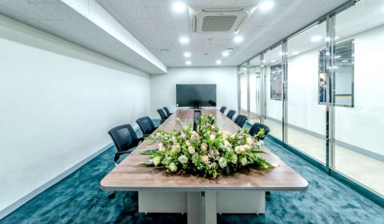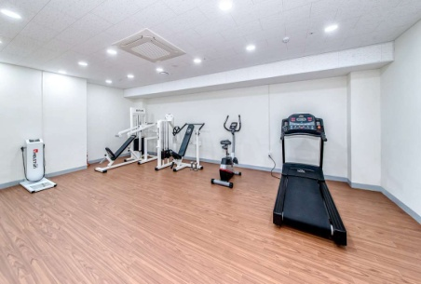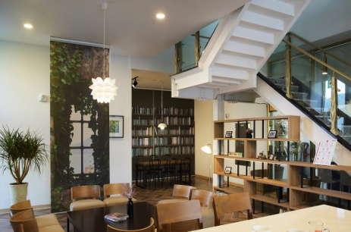

** HOTEL INFORMATION**

|  |  |
| --- | --- |
| ***For JEJU KOREA OPEN INTERNATIONAL TAEKWONDO CHAMPIONSHIPS 2018*** | ***July 18 -24, 2018*** |

**Hotel The One**

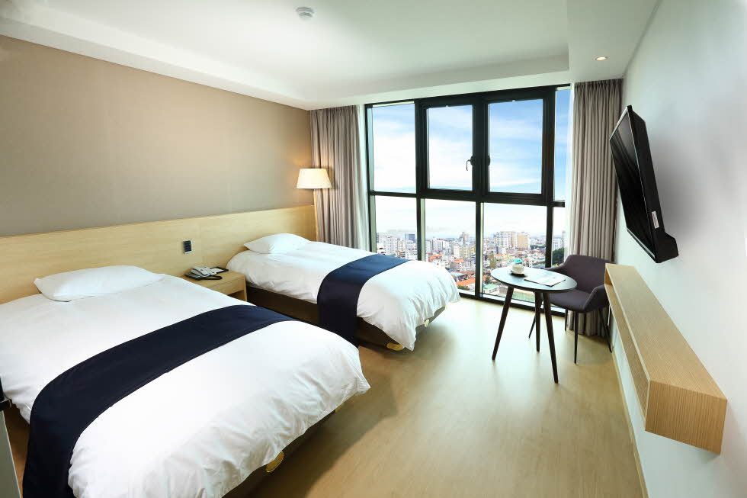

**Access  
Jeju International Airport to Hotel:** 12 minutes, about 3.2 km  
**Hotel to Halla Gymnasium:** 12 minutes, about 3.2km

**Facility**

- Convention Hall

- Sky Park

- Business Center

- Tour Consulting

**Room facility**

2 free bottled water per day, free tea service, bathrobe, slippers, air conditioner, telephone, kettle, LED TV, flashlight, multi outlet, bidet, hair dryer, shower cap, cotton swabs, wash towel, bath towel, soap, comb, shampoo, conditioner, body wash, body lotion, safety box.



