Tour RESERVATION FORM
For JEJU KOREA OPEN INTERNATIONAL TAEKWONDO CHAMPIONSHIPS 2018 | July 18 -24, 2018

The Organizing Committee of the JEJU Korea Open International Taekwondo Championships 2018 has prepared the accommodation and tour packages for the participants and accompanying people during the championships. All reservation requests for accommodation and tour package will be handled by Rye Tour, Official Travel Agency of JEJU Korea Open International TKD Championships 2018.
Reservations are proceeded first come first served on a basis, and you are kindly advised to return your completed reservation form by 30 May, 2018. Please complete the reservation form as indicated and submit it by fax, e-mail or direct mail to the address below. For further inquiry,

Date | Time | Tour Name | Course | Price
7/19 | 1:00pm~5:00pm | T1  Jeju City | Jeju Dongmun Market Place - Yongduam - Folklore & Natural History Museum - Samsunghyeol | $40
7/19 | 1:00pm~5:00pm | T2  Hallim Park | Hallim Park | $40
7/20 | 9:00am~1:00pm | T3  Andeok- Daejeong | Mt. Songak - Gotjawal - Jumeoktap | $40
7/20 | 9:00pm~1:00pm | T4  Jocheon - gujwa | Sangumburi - Manjanggul | $40
7/21,22 | 1:00pm~5:00pm | T5  Seongsan | Seongsan Ilchulbong Peak(UNESCO Natural Heritage Site) - Ilchul Land | $40
7/22,23 | 9:00pm~5:00pm | T6  Jungmun - Seoguipo | BotanicGarden Yeomiji - Jusangjeolli Cliff - Yakchunsa - Cheonjiyeon Fall | $90
7/22,23 | 9:00pm~5:00pm | T7  Seongsan - Pyoseon | Seongsan Ilchulbong Peak(UNESCO Natural Heritage Site) - Jeju Folk Village - Haenyeo Museum - Jeju Aqua Planet | $90
**Minimum 10 people are require to operate each tour.

Please fill out this tour reservation form
Tour Reservation
Nationality
Leader’s name |  | Group name
E-mail address
Phone Number
Tour Name |  | Number of People
Tour Date

Return this form to:
Address | #309, Dong-A Bldg, 7, Gukhoe-daero 70-gil, Yeongdeungpo-gu, Seoul, 07238 Korea
Tel | +82 2 725-0808
Fax | +82 2 761-4808
E-mail | ryetour11@gmail.com  ryetour01@gmail.com

Tour INFORMATION
For JEJU KOREA OPEN INTERNATIONAL TAEKWONDO CHAMPIONSHIPS 2018 | July 18 -24, 2018
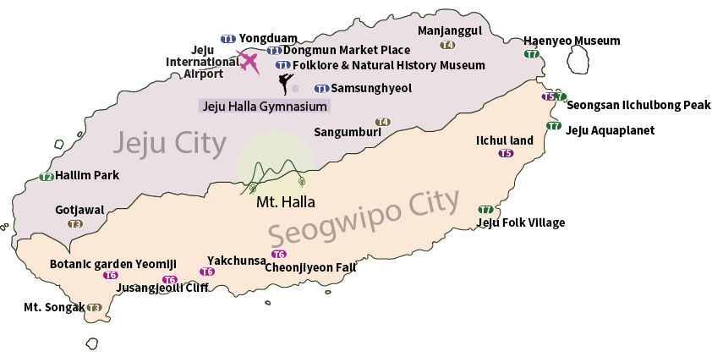
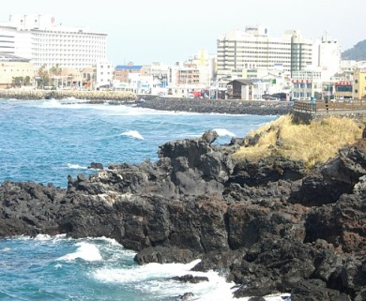
Yongduam is named after the dragon's head because the shape of the rocks look like the imaginary creature.
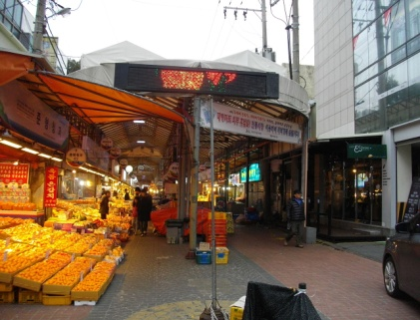
Dongmun Market is the biggest and oldest market is Jeju.

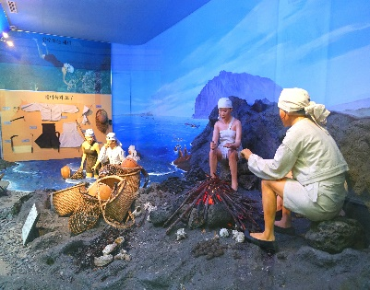
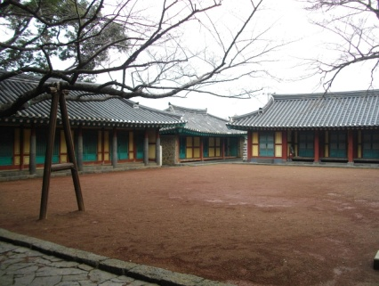
Samsunghyeol is the one of the oldest historical shrine in Jeju where you can see the relics in the museum.
Folklore & Natural History Museum displays traditional remainings

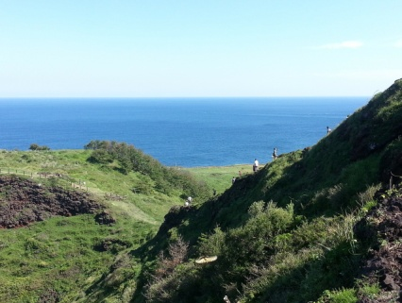
Hallim Park has 9 themed areas where you can enjoy feeling nature.
Gotjawal is a forest, unique geographical nature is a beautiful garden to hike.
Mt. Songak is located on the most southern part of Jeju, with great view of sea and nature.
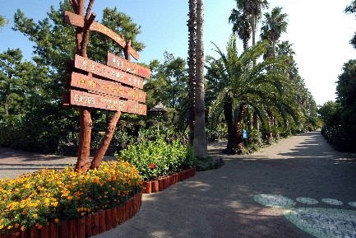
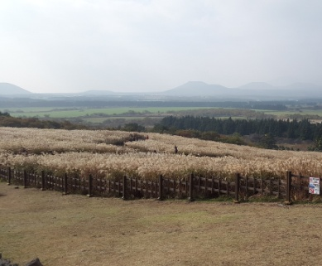
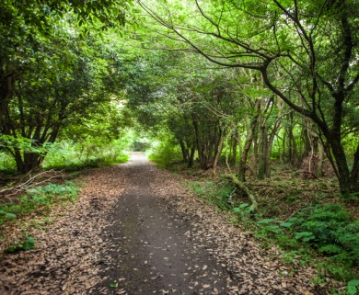
Sangumburi is a crater which dimension is 750 meter and 115 meter depth.

Tour INFORMATION
For JEJU KOREA OPEN INTERNATIONAL TAEKWONDO CHAMPIONSHIPS 2018 | July 18 -24, 2018

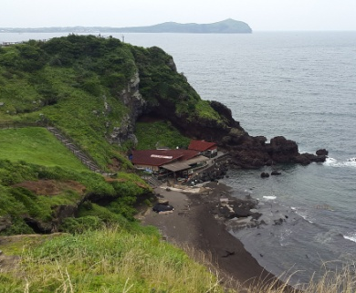
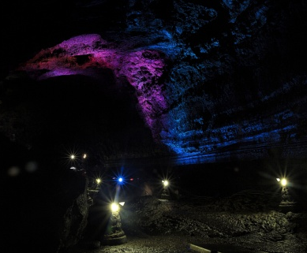
Seongsan Ilchulbong Peak, a UNESCO Natural Heritage Site, was formed by volcanic activity about 5,000 years ago.
Manjanggul is a lava cave that is on the list of UNESCO World Nature site.

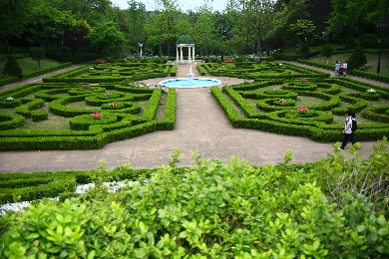
Botanic Garden Yeomiji has various themed indoor and outdoor gardens where 180 plants from 130 courtiers grow.
Ilchul Land is a botanical big garden with a cave.
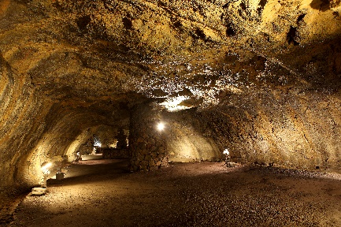
Jusangjeolli Cliff is a volcanic rock at the southern coast.
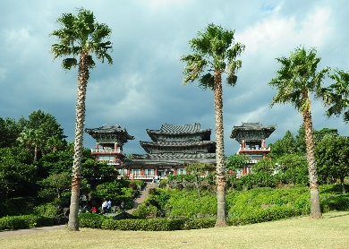
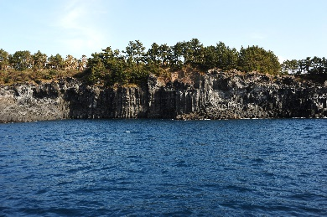
Yakchunsa was built in 1960. The palm trees in the temple has full of tropical atmosphere.

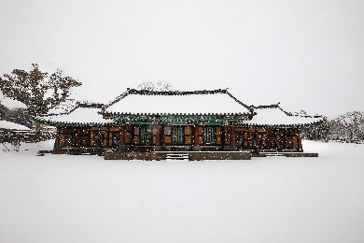
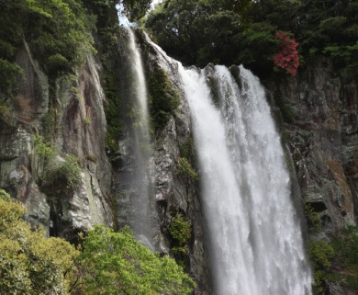
Jeju Folk Village has many traditional folklore materials and you can see old living culture.
Cheonjiyeon Falls
It is 22-meter hight and 12-meter width and many protected species and natural treasure live in the valley.

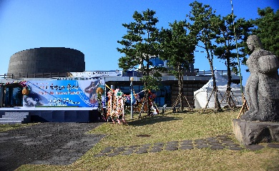
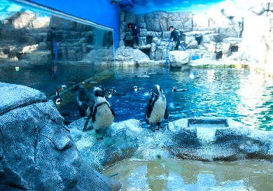
Jeju Aqua Planet is hte largest aquarium in Asia that nearly 50,000 animals and plants are in.
Haenyeo Museum displays materials related to women divers and fishing cillages.

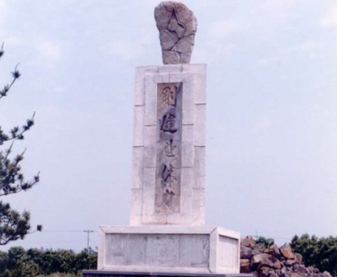
Fist Tower– It originates from General Choi, Hong Hee who named & established Taekwondo for the first time in 1953 at Moseulpo, Jeju Isand when he was the commander of 29th Division of Korean Army. General Choi is known as the person who named Martial Arts Taekwondo and laid the foundation for Taekwondo by laying military-style salute ‘ Taekewon’ or got soldiers Taekwondo training.

